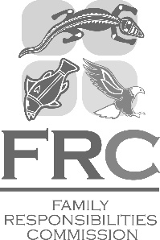 | Family Responsibilities Commission  Cairns Commonwealth Centre  Level 3, 107 Lake Street, Cairns  PO Box 5438  Cairns Qld 4870  Ph: 07 4081 8400  Fax: 07 4041 0974  www.frcq.org.au

17 October 2023

The Honourable Leeanne Enoch MP
Minister for Treaty,
Minister for Aboriginal and Torres Strait Islander Partnerships,
Minister for Communities and Minister for the Arts
GPO Box 806
BRISBANE QLD 4001

Dear Minister Enoch

I am pleased to submit for presentation to the Parliament the Annual Report 2022-23 including financial statements for the Family Responsibilities Commission.

I certify that this Annual Report complies with:
- the prescribed requirements of the Financial Accountability Act 2009 and the Financial and Performance Management Standard 2019, and
- the detailed requirements set out in the Annual Report Requirements for Queensland Government Agencies.

A checklist outlining the annual reporting requirements can be found at page 122 of this report.

Yours sincerely

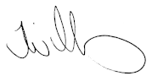
Tammy Williams
Commissioner
Family Responsibilities Commission

